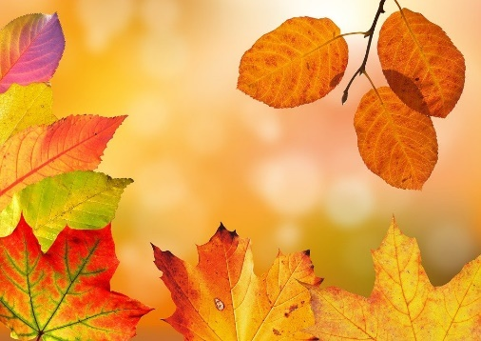
GREETINGS LARKS – It’s almost Fall. Yeah!!
The name September comes from the Latin septem, meaning seven, since it was the seventh month of the Roman calendar, which began with March.
September has three birth flowers: the Forget-Me-Not, the Morning Glory, and the Aster.
The Zodiac s are Virgo and Libra, Birthstone is the Sapphire, and the flowers are Gladiolus and Poppy.
Labor Day is observed on the first Monday of each September. September has several United States and international holidays.
Our Lark birthdays in Sep are Sandy on the 2nd, Patty on the 22nd, and Barb Costa on the 24th.

Our last Newsletter was June. So let’s celebrate July and August for a moment.
Our Lark birthday in July is Nancy on the 27th.
July celebrates National Hot Dog Month and most importantly, National Ice Cream Month. And let’s not forget Independence Day on the 4th. The Ruby is the birthstone, and flowers are Larkspur and Water Lily. Zodiac signs are Cancer and Leo. It was in July when the first-ever telephone call was made. It took place between Canada and the US in 1881.

August is a popular male name. Lammas Day is the first of August and celebrates the harvest of wheat and corn. In August 1762 the sandwich as we know it today was created when the Earl of Sandwich asked for meat between two pieces of bread. Our Lark birthdays in August are Karen on the 8th, and Barb Robertson on the 22nd. Birthstones are the Peridot, which is light green, and alternates Sardonyx and newly named Spinel. Leo and Virgo are the zodiac signs.

Happy Birthdays, and if I’ve missed anyone let me know.

We are having a meeting at 2PM at the Hawthorne downtown this Sunday. Barb is busy getting the agenda in order. Hope to see a lot of you there. We will elect new officers who will be seated in January. Please be thinking if you would like to step up and take an officer position on. Officer positions are President, VP, Treasurer and Secretary. Our current slate, Barb R as president, Mary Lee as VP, Trish as Treasurer, and Karen as Secretary will be stepping down. They have had a long reign.

I will be doing Progress Reports on activities that we have done so far this year. It’s been a little quieter this year than last, so please be looking for projects that we can take on and present them to the club.

Congratulations are in order for Trish, who is our new GFWC WY president, and Karen who is our new GFWC WY VP. They were elected in April at the state convention in Thermopolis.

Welcome new members Carmalee Rose and Trudy Clarke.

Hope to see you Sunday. Stay Safe.

Flo

